Windows Server 2016

How to Configure AD DS (Domain Controller)

Steps to setup Active Directory

* From the Server Manager Dashboard, click on **Add roles and features**. **[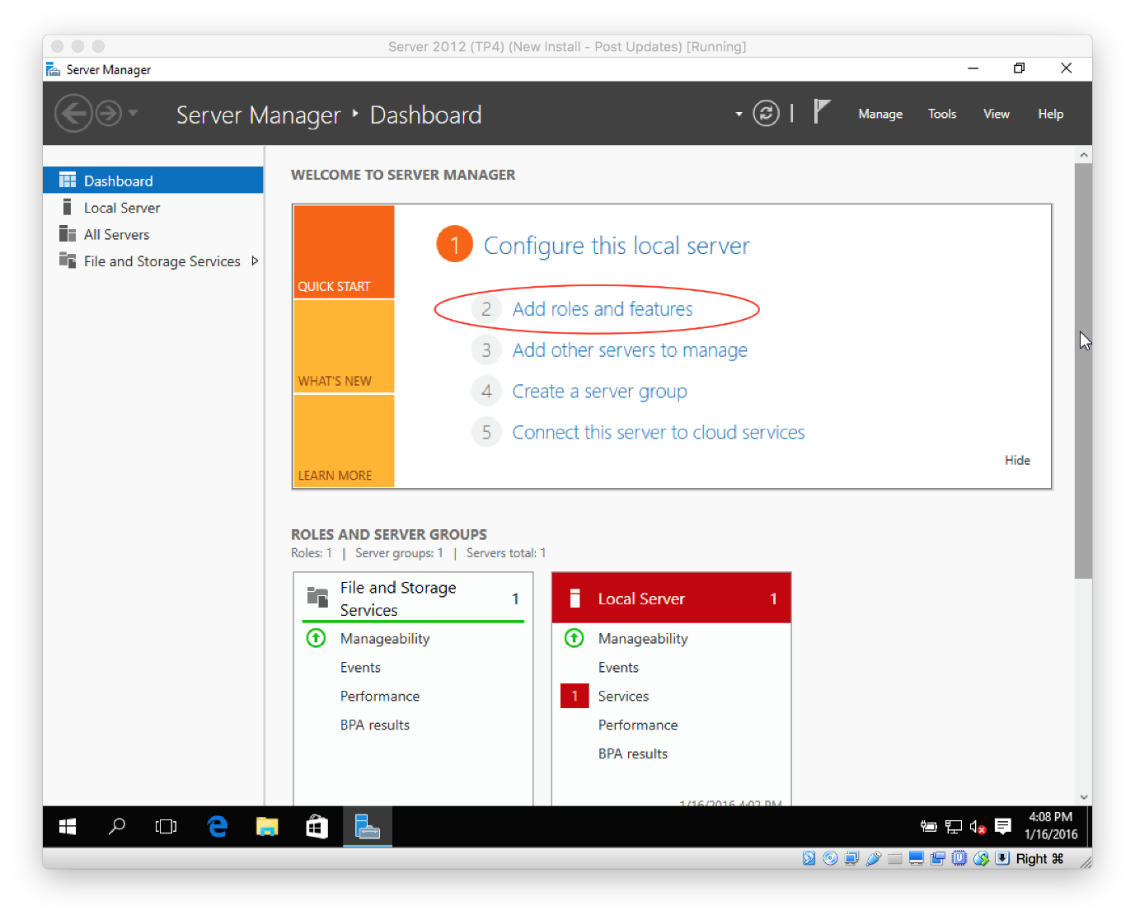](https://secureservercdn.net/198.71.233.195/dbd.2d9.myftpupload.com/wp-content/uploads/2016/01/Setup-Server-2016-1.png)**
* Select **Role-based or feature-based installation** and click **Next**.  
  [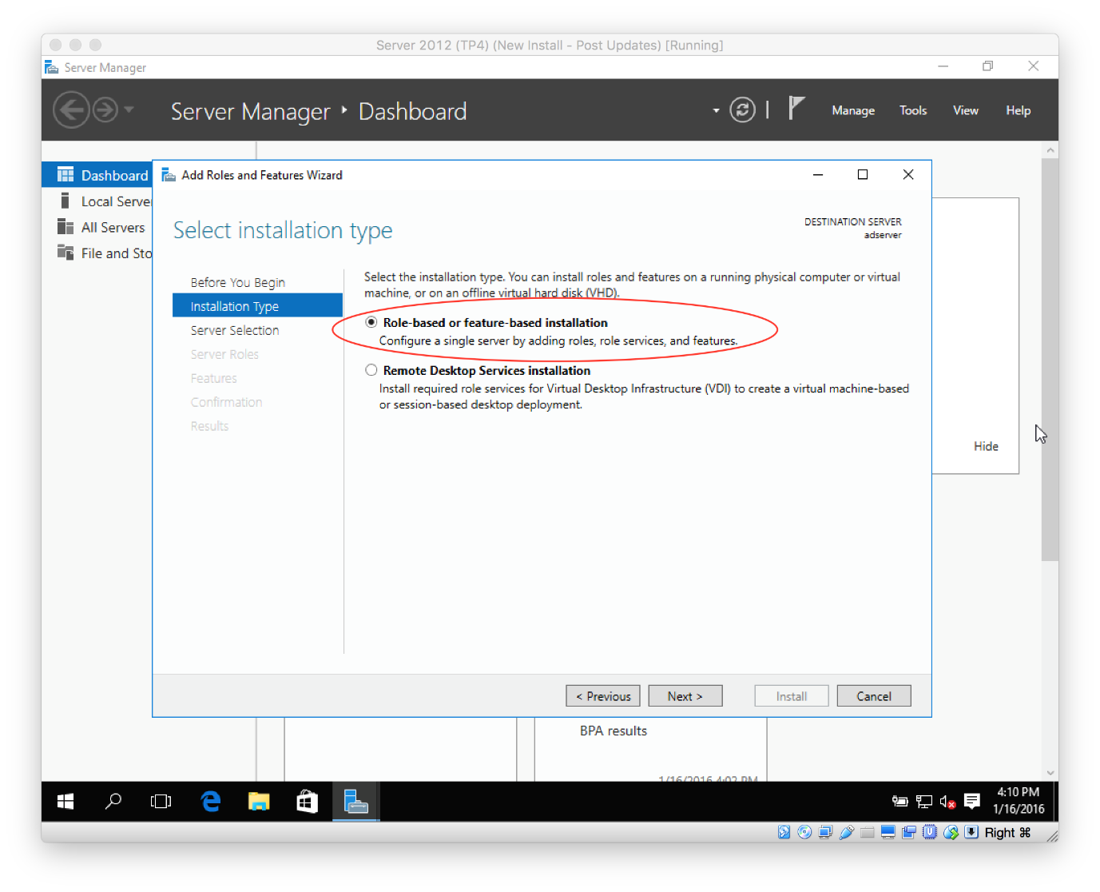](https://secureservercdn.net/198.71.233.195/dbd.2d9.myftpupload.com/wp-content/uploads/2016/01/Setup-Server-2016-2.png)
* Select the server by highlighting the row and select **Next**.  
  [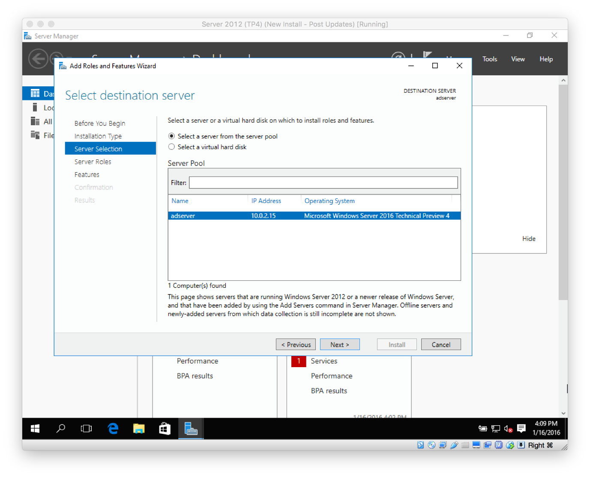](https://secureservercdn.net/198.71.233.195/dbd.2d9.myftpupload.com/wp-content/uploads/2016/01/Setup-Server-2016-3.png)
* Select **Active Directory Domain Services** and then select **Next**.  
    
  [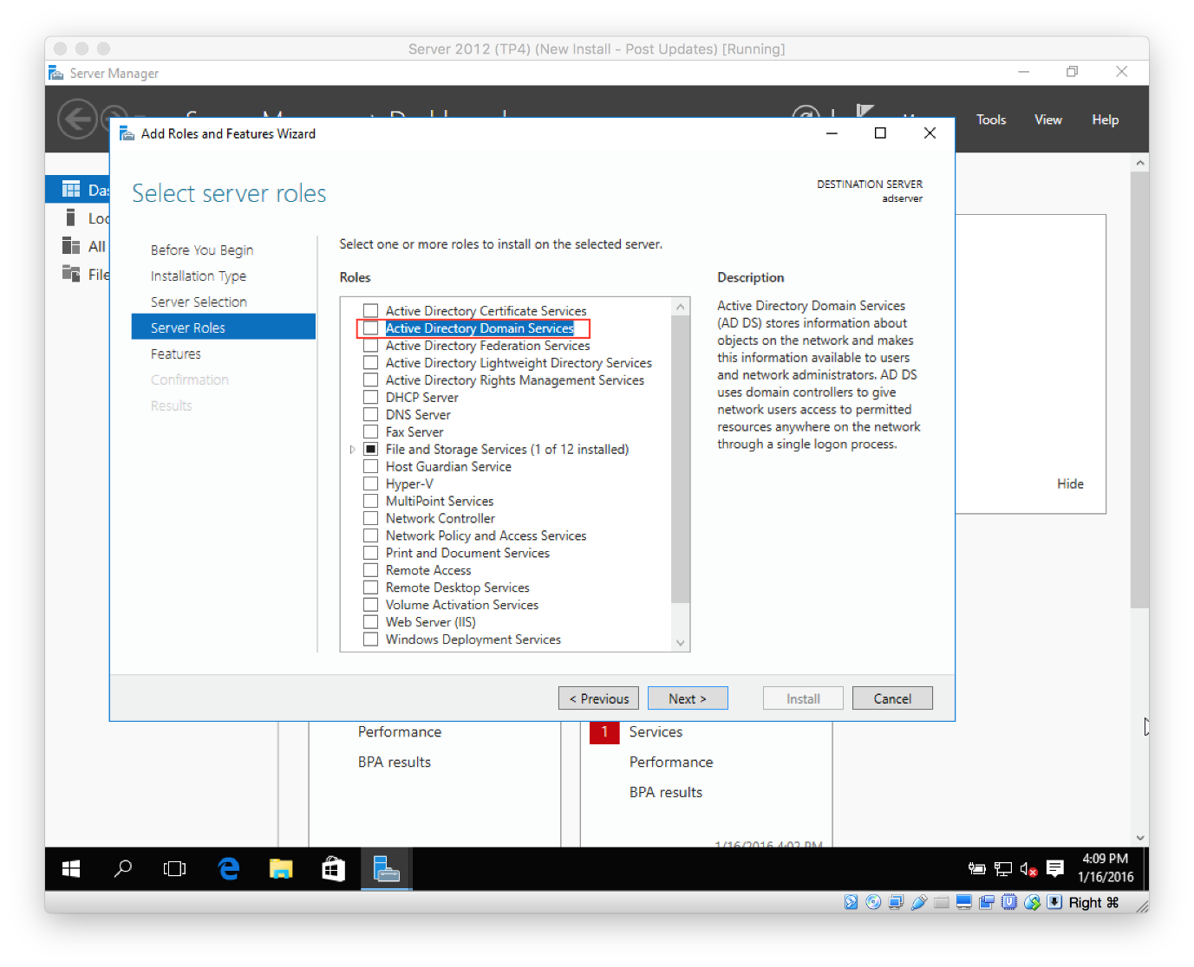](https://secureservercdn.net/198.71.233.195/dbd.2d9.myftpupload.com/wp-content/uploads/2016/01/Setup-Server-2016-4.png)
* Click **Add Features**.  
  [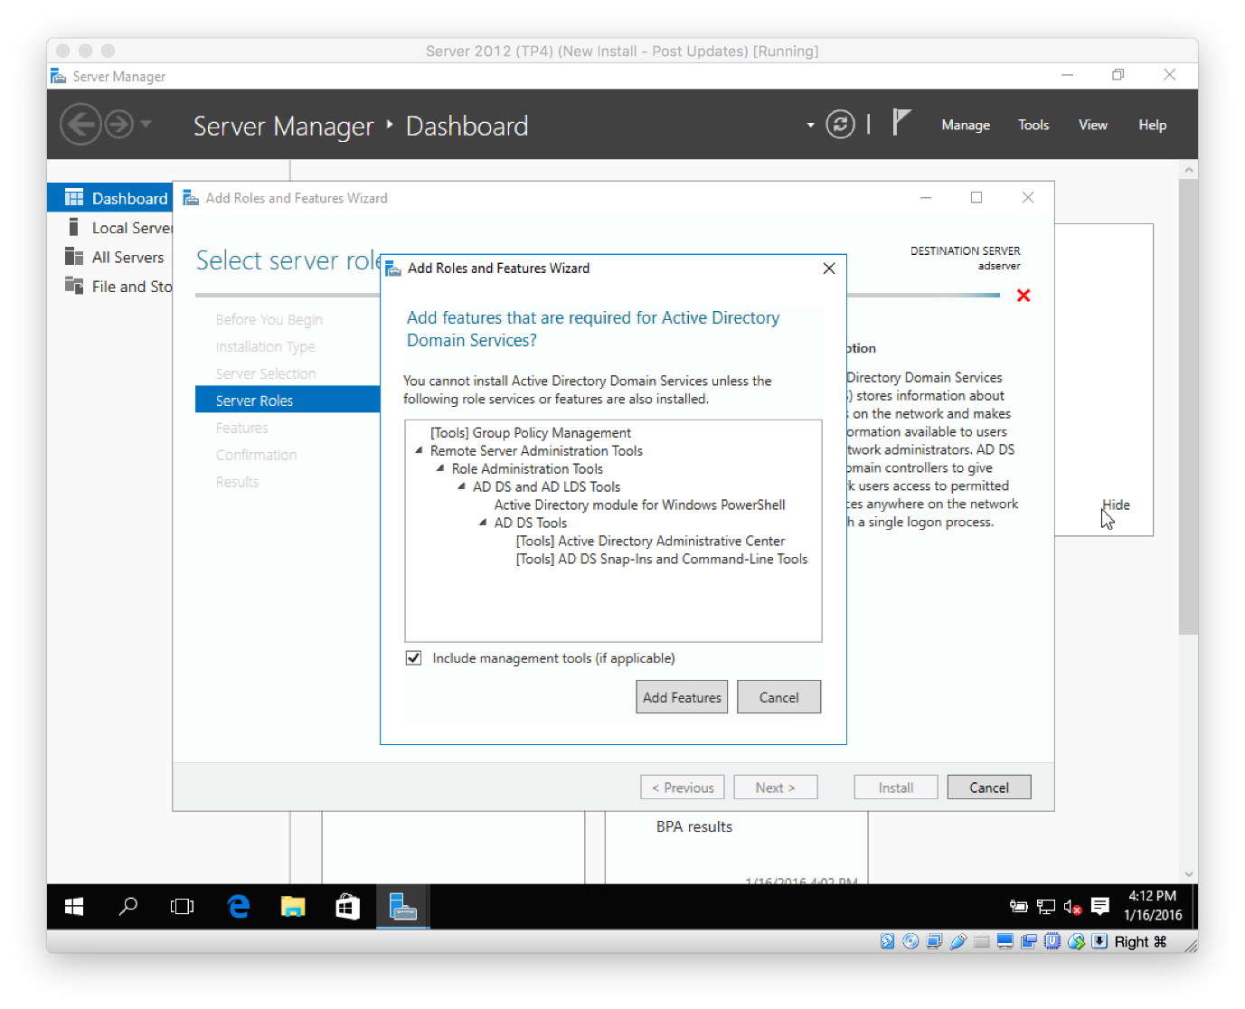](https://secureservercdn.net/198.71.233.195/dbd.2d9.myftpupload.com/wp-content/uploads/2016/01/Setup-Server-2016-5.png)
* You shouldn’t have to select anything at the Select features, so just select **Next**.  
  [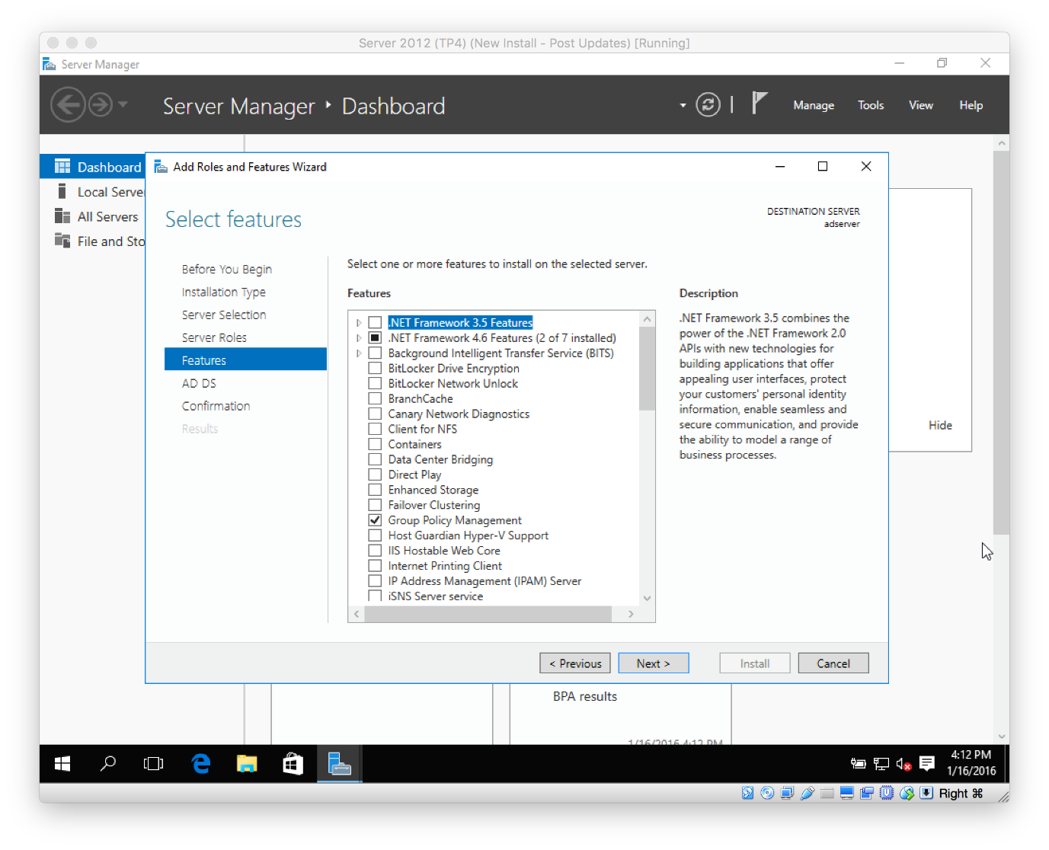](https://secureservercdn.net/198.71.233.195/dbd.2d9.myftpupload.com/wp-content/uploads/2016/01/Setup-Server-2016-6.png)
* Click **Next** in the **AD DS** section.  
  [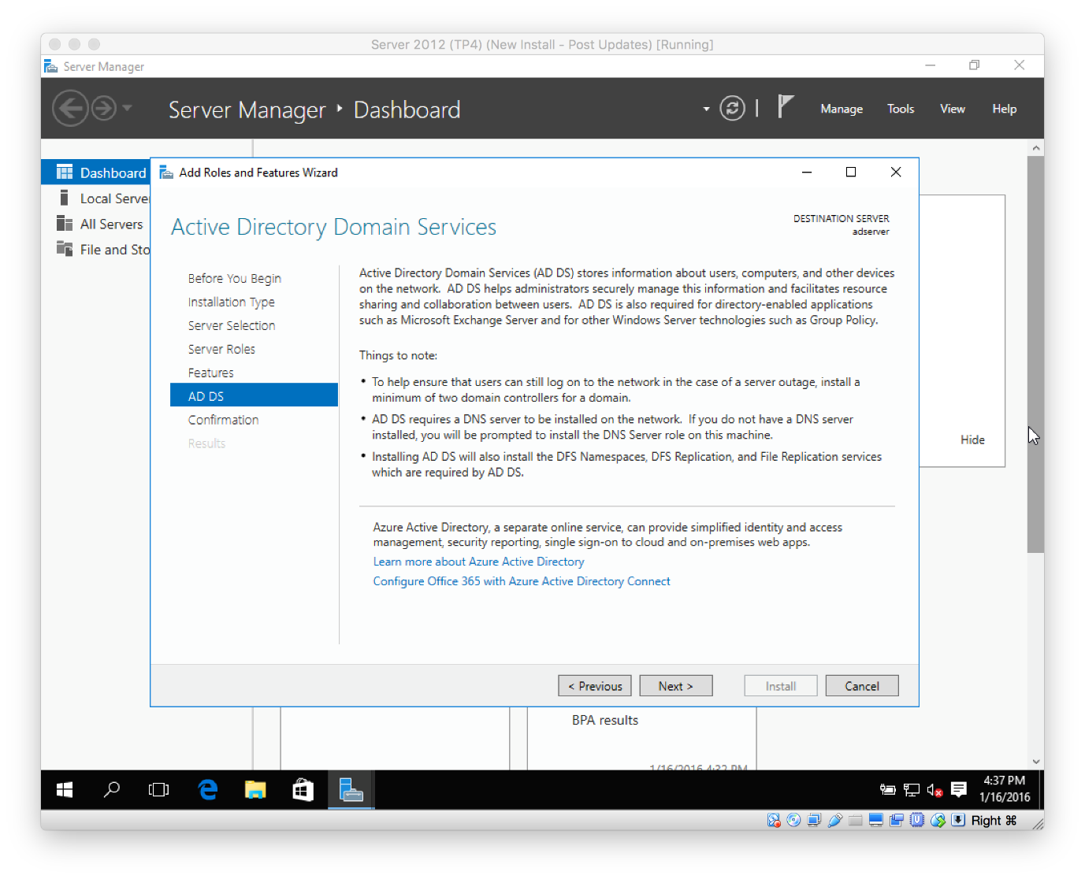](https://secureservercdn.net/198.71.233.195/dbd.2d9.myftpupload.com/wp-content/uploads/2016/01/Screen-Shot-2016-01-16-at-4.37.15-PM.png)
* On the **confirmation window**, review everything and then click **Install**.  
  [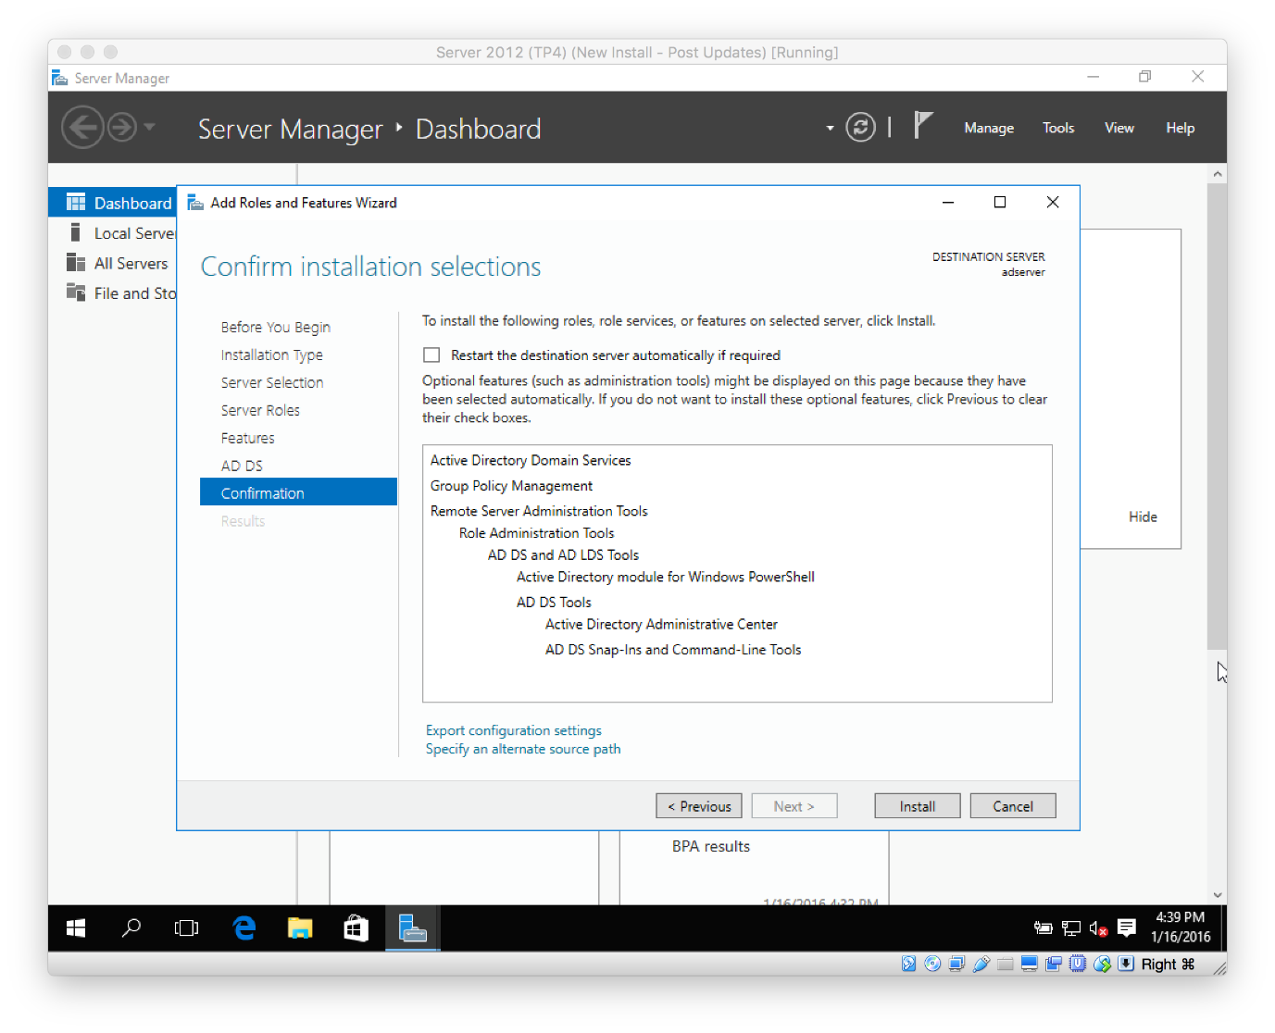](https://secureservercdn.net/198.71.233.195/dbd.2d9.myftpupload.com/wp-content/uploads/2016/01/Screen-Shot-2016-01-16-at-4.39.47-PM.png)
* The installation will begin.
* When the installation is complete, you need to now promote the server to a domain controller.
* Click **Promote this server to a domain controller**(small hyperlink in the results window)  
  [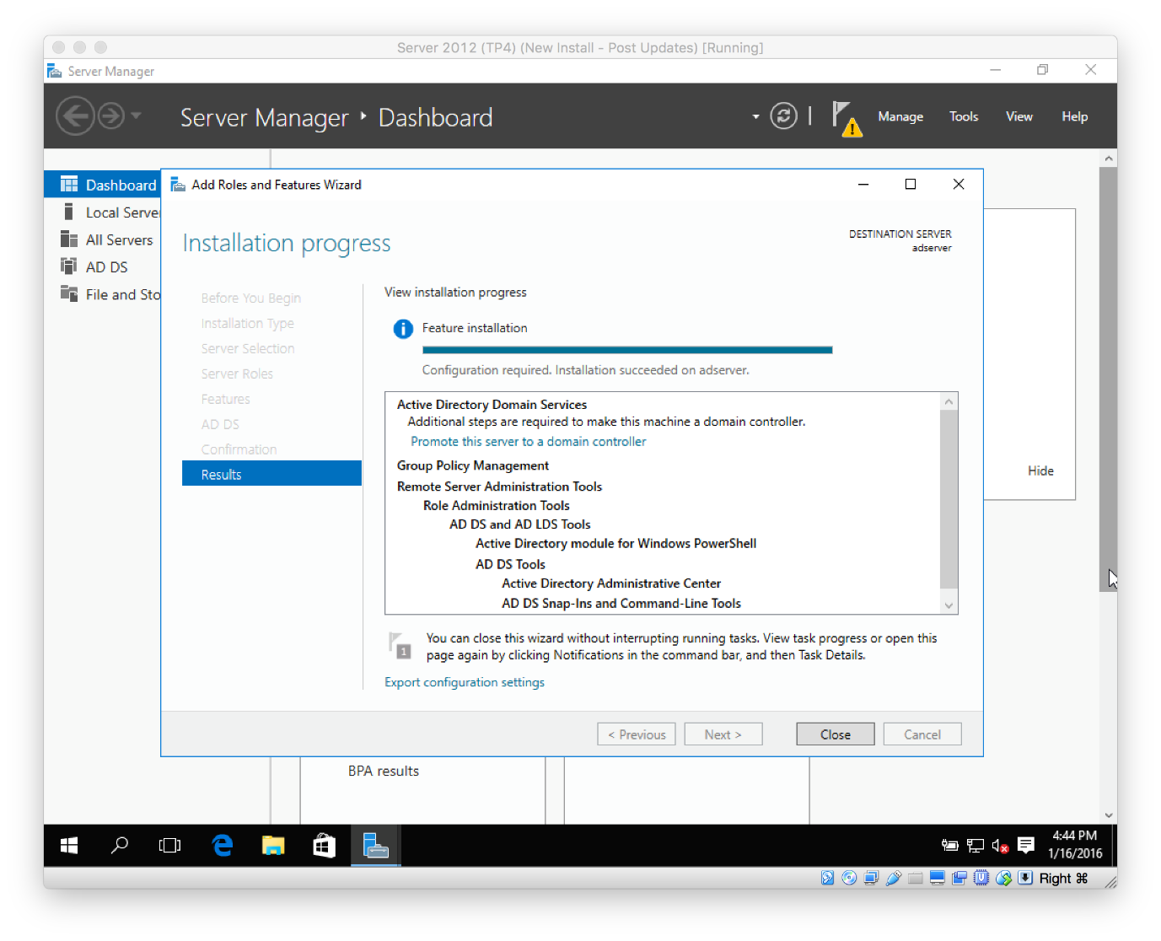](https://secureservercdn.net/198.71.233.195/dbd.2d9.myftpupload.com/wp-content/uploads/2016/01/Screen-Shot-2016-01-16-at-4.44.57-PM.png)
* Or, if you are like me and you clicked Close, **click** on the **yellow exclamation mark** in the upper-right section of the Server Manager Dashboard.  
  [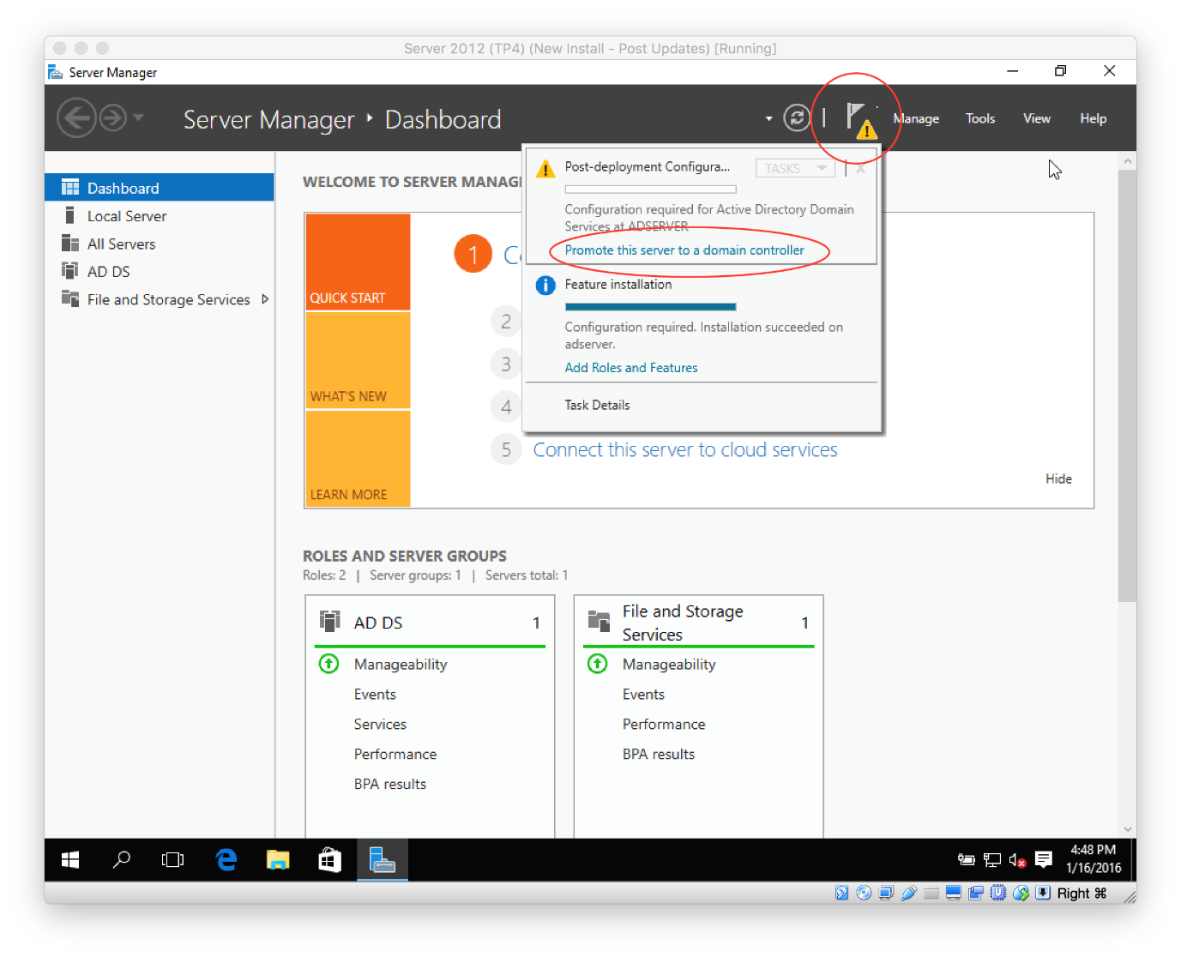](https://secureservercdn.net/198.71.233.195/dbd.2d9.myftpupload.com/wp-content/uploads/2016/01/Screen-Shot-2016-01-16-at-4.48.17-PM.png)
* Select **Add a new forest**, **type in a domain name** that you want to use (pro-tip: use something like <something>.internal), then click **Next**.  
  [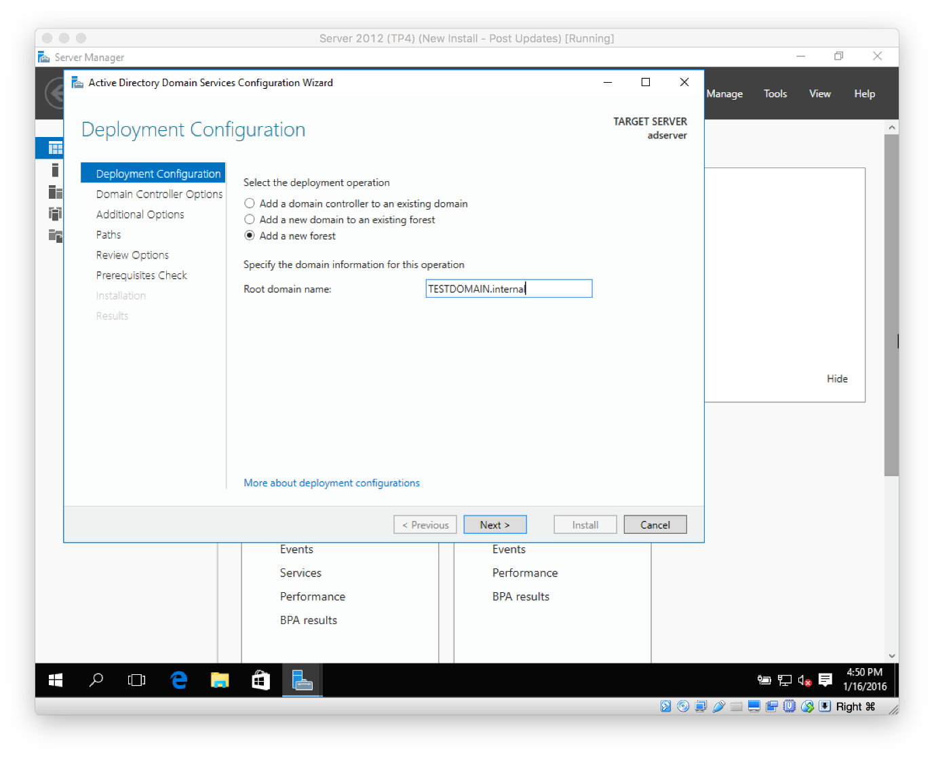](https://secureservercdn.net/198.71.233.195/dbd.2d9.myftpupload.com/wp-content/uploads/2016/01/Screen-Shot-2016-01-16-at-4.50.44-PM.png)
* **Type in a password** you want to use for DSRM, then click **Next**.  
  [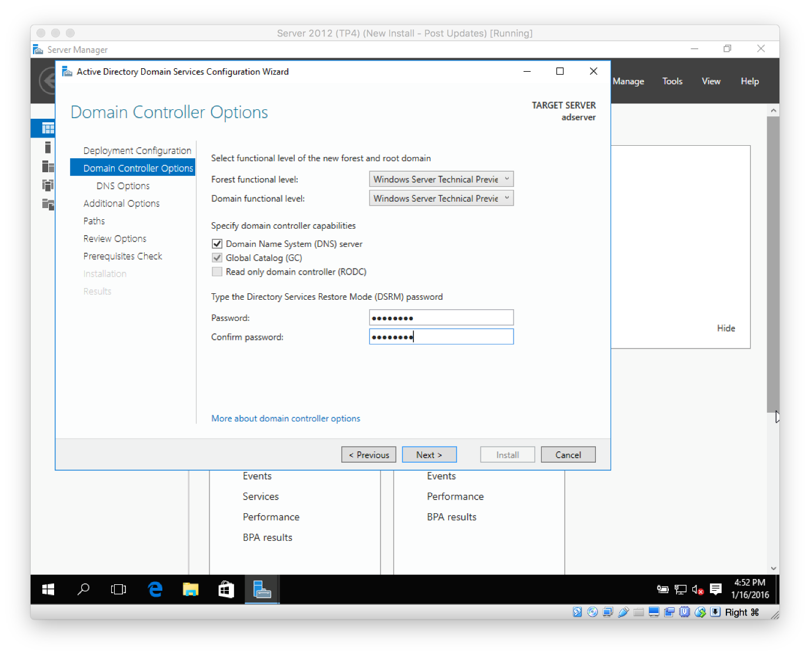](https://secureservercdn.net/198.71.233.195/dbd.2d9.myftpupload.com/wp-content/uploads/2016/01/Screen-Shot-2016-01-16-at-4.52.53-PM.png)
* Click **Next** on the **NDS Options** page.  
  [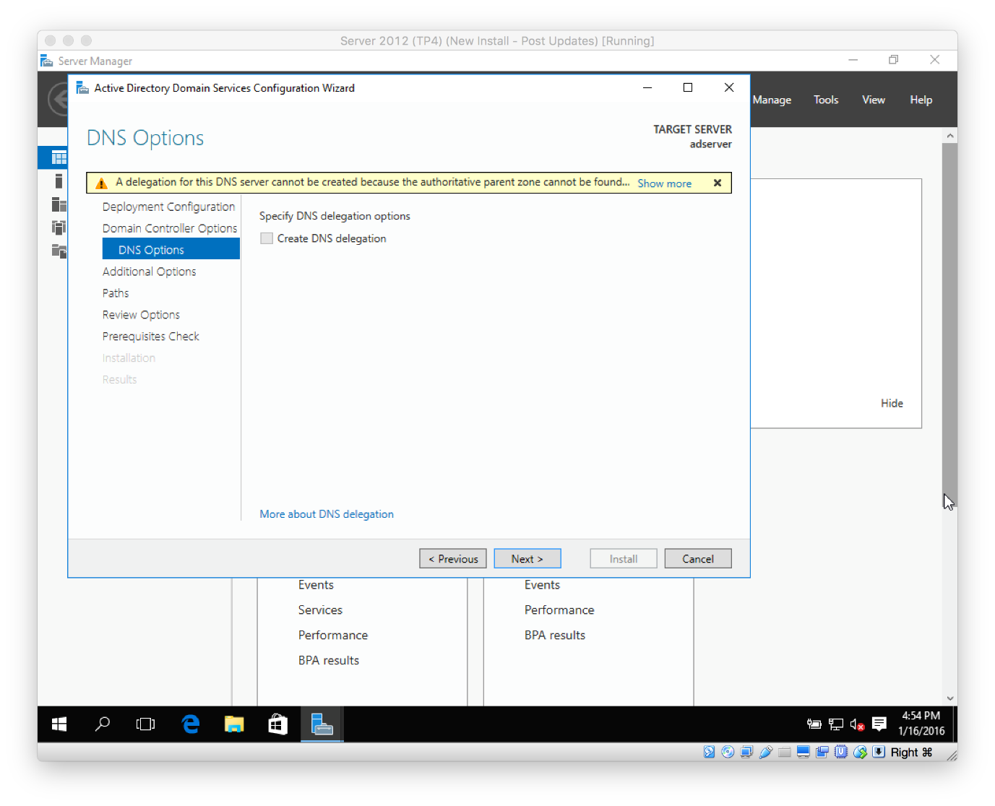](https://secureservercdn.net/198.71.233.195/dbd.2d9.myftpupload.com/wp-content/uploads/2016/01/Screen-Shot-2016-01-16-at-4.54.32-PM.png)
* Click **Next** in the **Additional Options** page.  
  [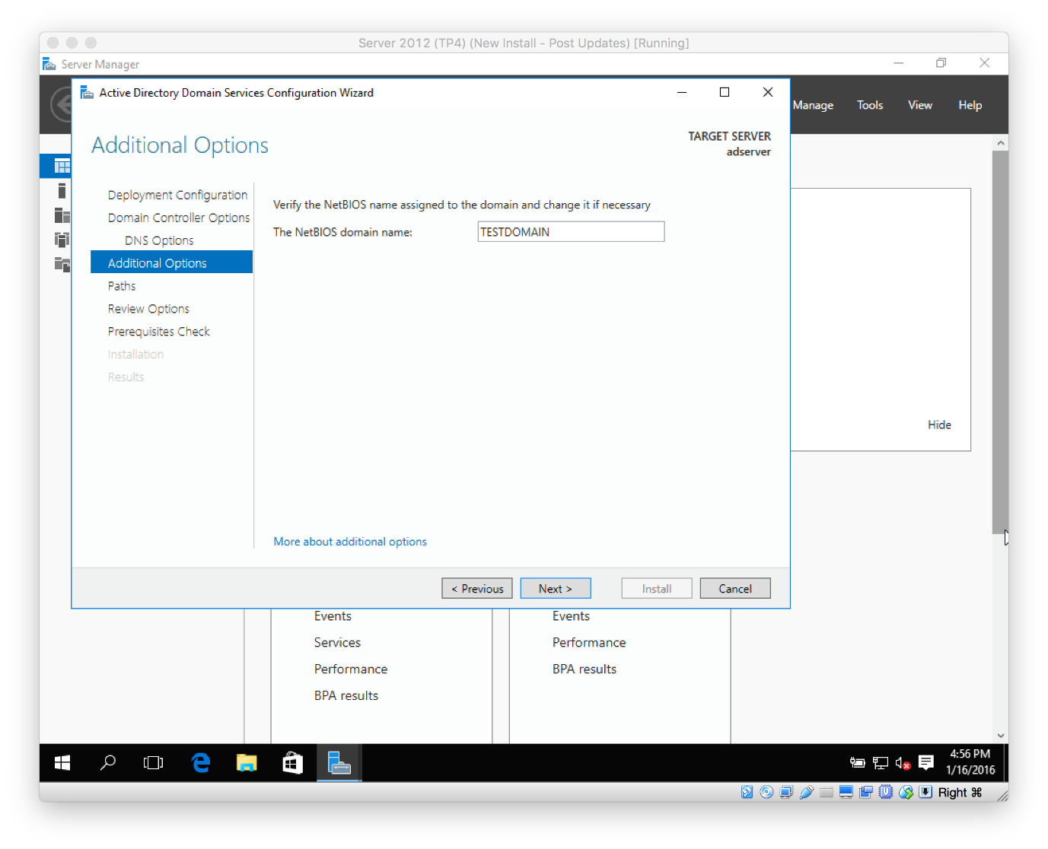](https://secureservercdn.net/198.71.233.195/dbd.2d9.myftpupload.com/wp-content/uploads/2016/01/Screen-Shot-2016-01-16-at-4.56.10-PM.png)
* Click **Next** on the **Paths** sections.  
  **[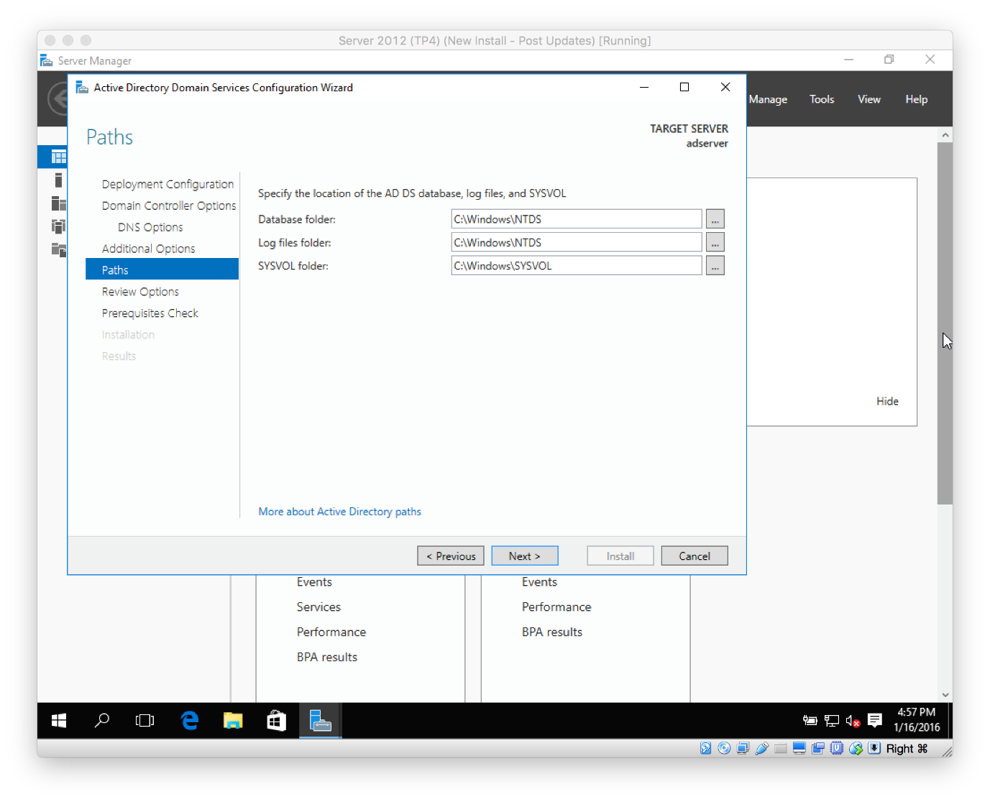](https://secureservercdn.net/198.71.233.195/dbd.2d9.myftpupload.com/wp-content/uploads/2016/01/Screen-Shot-2016-01-16-at-4.57.55-PM.png)**
* Click **Next** on the **Review Options** screen, then click **Install** on the **Prerequisites Check** page.  
  [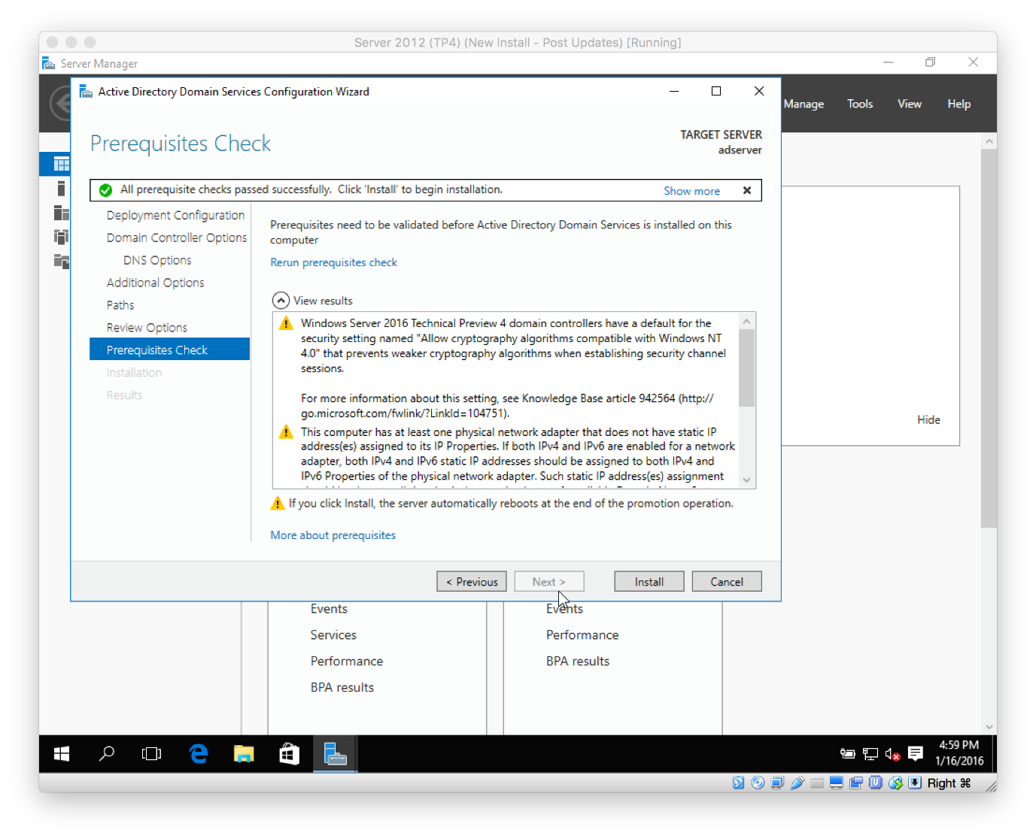](https://secureservercdn.net/198.71.233.195/dbd.2d9.myftpupload.com/wp-content/uploads/2016/01/Screen-Shot-2016-01-16-at-4.59.58-PM.png)
* The installation (promotion process) will begin. The server will reboot during this process.
* When the installation is complete, log back in (this time you will be logging into the server with domain credentials).
* Let’s verify Active Directory is setup and our server is classified as a DC (domain controller).
* From within **Server Manager**, click **Tools** then **Active Directory Users and Computers**.  
  [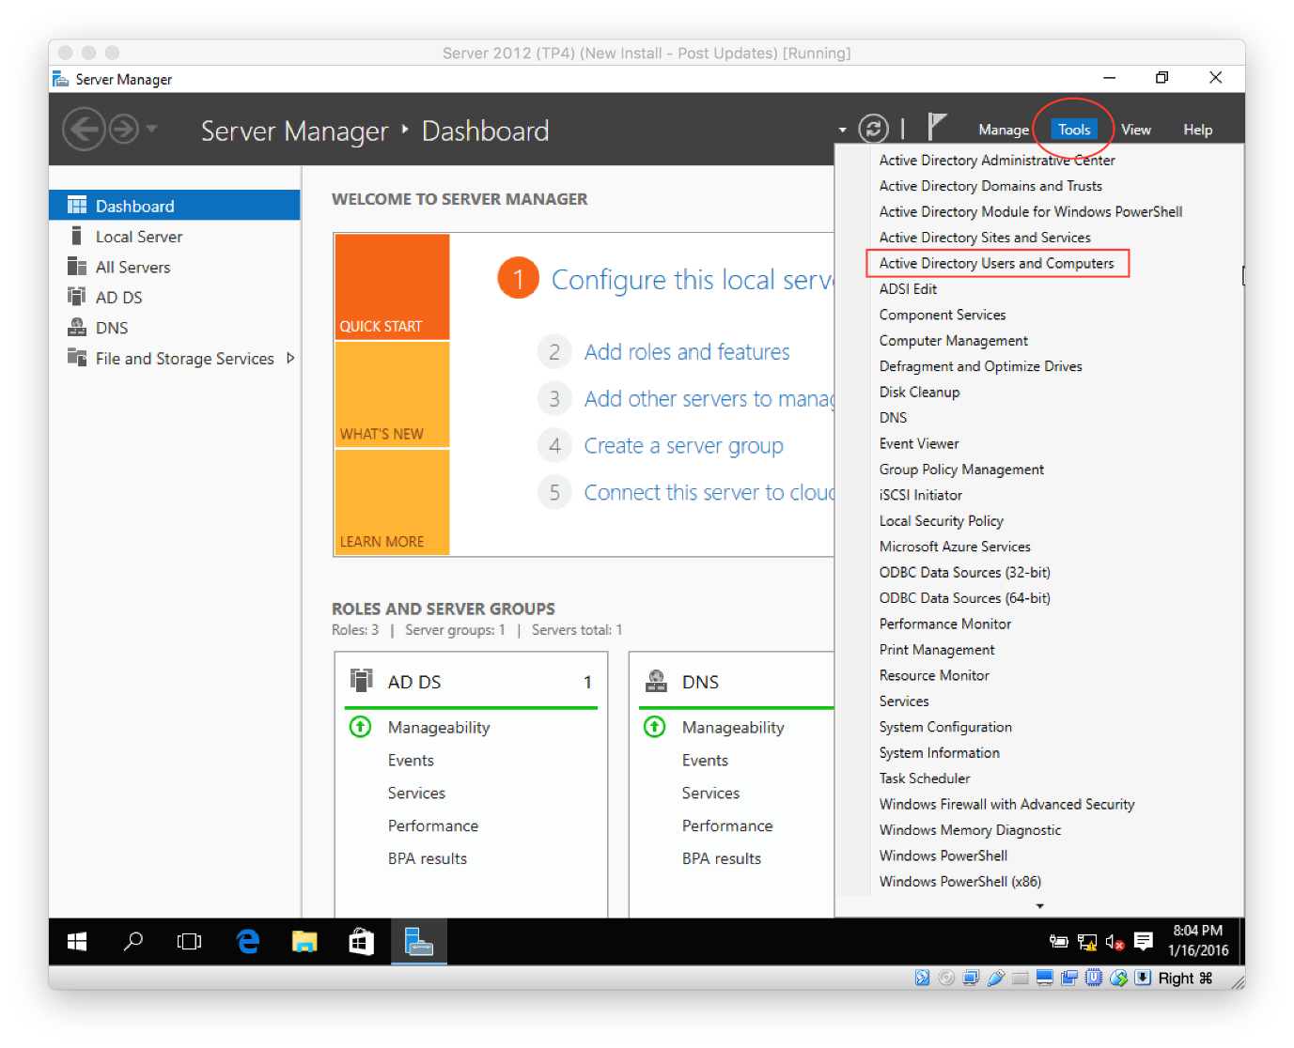](https://secureservercdn.net/198.71.233.195/dbd.2d9.myftpupload.com/wp-content/uploads/2016/01/Screen-Shot-2016-01-17-at-3.52.56-AM.png)
* **Expand the domain root** (in my case, it’s TESTDOMAIN.internal), then click on **Domain Controllers**.  
  [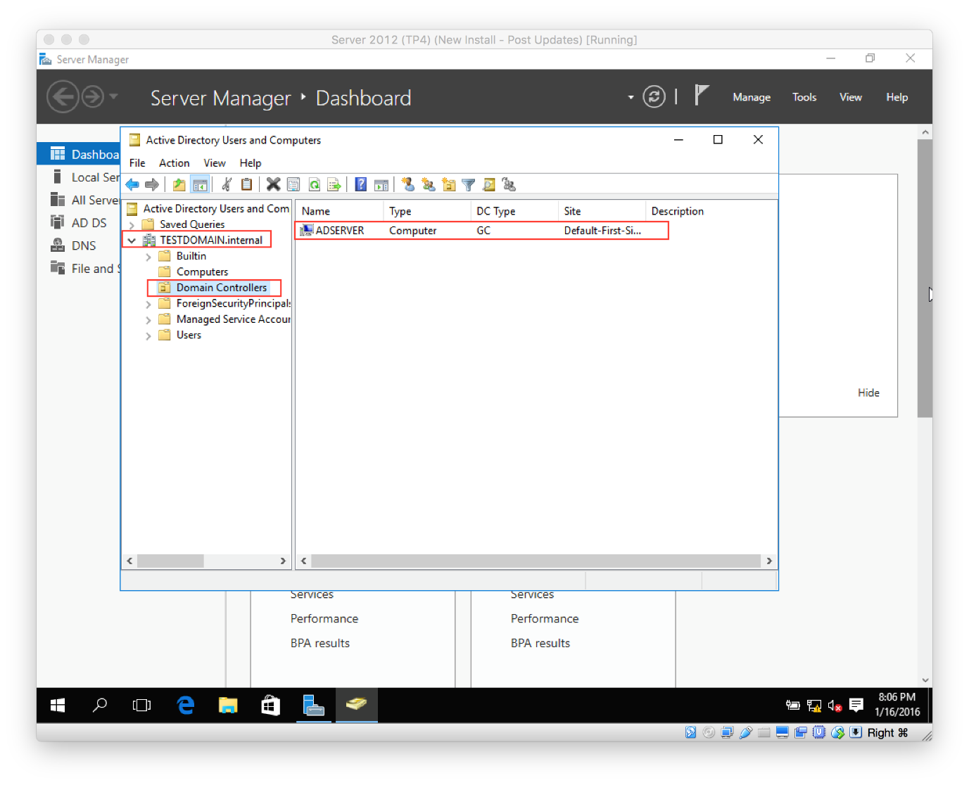](https://secureservercdn.net/198.71.233.195/dbd.2d9.myftpupload.com/wp-content/uploads/2016/01/Screen-Shot-2016-01-17-at-3.54.11-AM.png)
* You should see your new server being displayed.
* One las thing I want to do at this point is enable RDP (Remote Desktop Protocol).
* From **Server Manager Dashboard**, click **Local Server** then click **Disabled** next to Remote Desktop.  
  [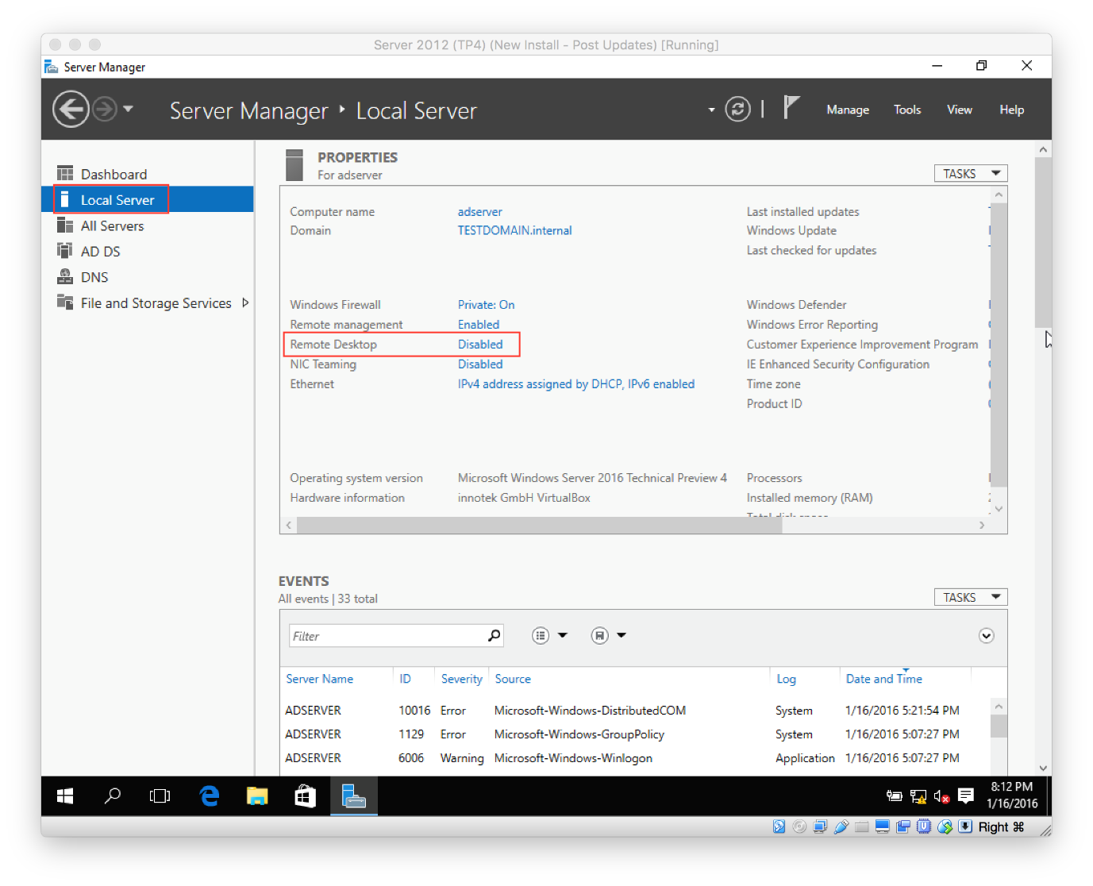](https://secureservercdn.net/198.71.233.195/dbd.2d9.myftpupload.com/wp-content/uploads/2016/01/Screen-Shot-2016-01-17-at-4.00.04-AM.png)
* Select **Allow remote connections to this computer**
* **Uncheck** the option **Allow connections only from computers running Remote Desktop with Network Level Authentication**, then click **OK**.  
  [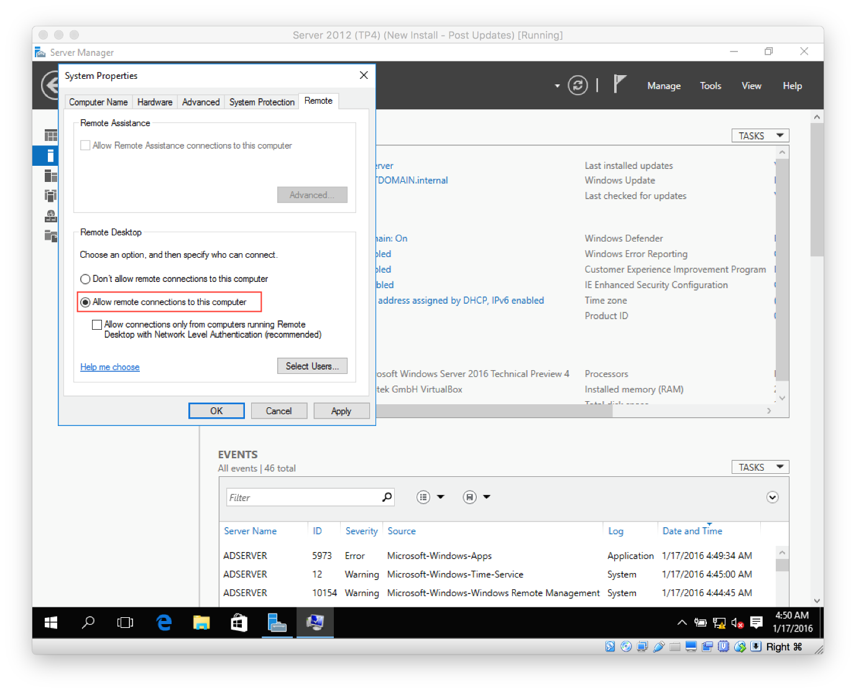](https://secureservercdn.net/198.71.233.195/dbd.2d9.myftpupload.com/wp-content/uploads/2016/01/Screen-Shot-2016-01-17-at-4.50.26-AM.png)